Ideation Phase
Define the Problem Statements

Date | 30 January 2026
Team ID | LTVIP2026TMIDS61992
Project Name | visualization tool for electric vehicle charge and range analysis
Maximum Marks | 2 Marks

Problem Statement:
Analyzing different data from Multiple sources for Electric cars in India and Globally. We have 4 Different datasets we need to analyse the data and create Dashboard and story that can represent the data and show the Visuals for the data.
Customer Problem Statement :
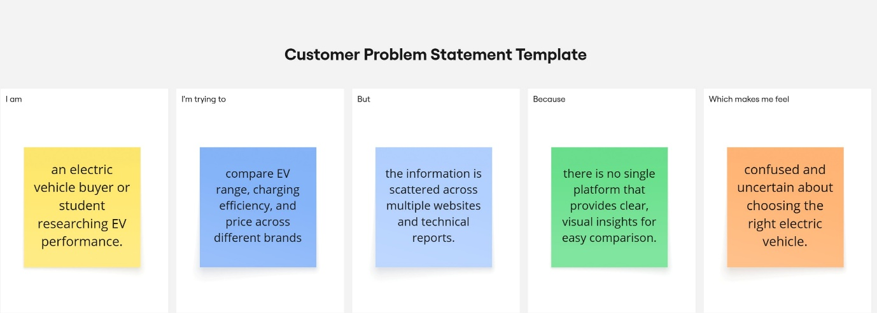

Problem Statement (PS) | I am (Customer) | I’m trying to | But | Because | Which makes me feel
PS-1 | An EV buyer or student researching electric cars | Compare EV range, price, and performance across brands | I cannot easily find all the data in one place | Information is scattered across multiple websites and sources | Confused and uncertain about which EV to choose
PS-2 | A user interested in EV charging and efficiency trends | Understand how charging range and cost vary between models | The available data is complex and hard to interpret | Most platforms show raw data without clear visual insights | Frustrated and overwhelmed by technical details

